Four bit digital tube

Overview：
这个实验控制四位数码管的显示。

Materials：
Arduino Uno x 1
Four bit digital tube x 1
breadboard x 1
DuPont wires x 12
220Ωresistor x 8

Product description :
功能：数码管是一种半导体发光器件，其基本单元是发光二极管。因此也需要串联电阻，以防电流过大。
应用：数码管广泛用于仪表，时钟，车站等。
引脚说明：
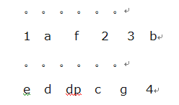

Technical Parameters ：
◆型号：BS共阳
◆尺寸：长30mm*宽度14mm*厚度7.2mm
◆发光颜色：高亮红色

Wiring diagram:
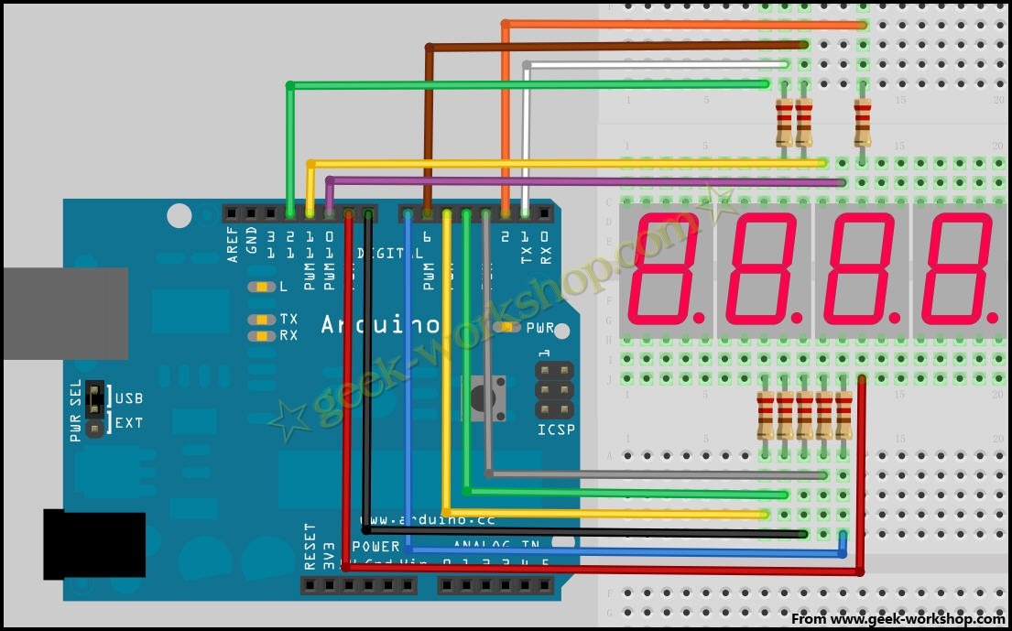

Example code:
int a = 1;
int b = 2;
int c = 3;
int d = 4;
int e = 5;
int f = 6;
int g = 7;
int dp = 8;
//Set anode interface
int d4 = 9;
int d3 = 10;
int d2 = 11;
int d1 = 12;
//Set variable
long n = 1230;
int x = 100;
int del = 55; //Here to fine tune the clock
void setup()
{
pinMode(d1, OUTPUT);
pinMode(d2, OUTPUT);
pinMode(d3, OUTPUT);
pinMode(d4, OUTPUT);
pinMode(a, OUTPUT);
pinMode(b, OUTPUT);
pinMode(c, OUTPUT);
pinMode(d, OUTPUT);
pinMode(e, OUTPUT);
pinMode(f, OUTPUT);
pinMode(g, OUTPUT);
pinMode(dp, OUTPUT);
}
/////////////////////////////////////////////////////////////
void loop()
{
Display(1, 1);

Display(2, 2);

Display(3, 3);

Display(4, 4);

}
///////////////////////////////////////////////////////////////
void WeiXuan(unsigned char n)//
{
switch(n)
{
case 1:
digitalWrite(d1,HIGH);
digitalWrite(d2, LOW);
digitalWrite(d3, LOW);
digitalWrite(d4, LOW);
break;
case 2:
digitalWrite(d1, LOW);
digitalWrite(d2, HIGH);
digitalWrite(d3, LOW);
digitalWrite(d4, LOW);
break;
case 3:
digitalWrite(d1,LOW);
digitalWrite(d2, LOW);
digitalWrite(d3, HIGH);
digitalWrite(d4, LOW);
break;
case 4:
digitalWrite(d1, LOW);
digitalWrite(d2, LOW);
digitalWrite(d3, LOW);
digitalWrite(d4, HIGH);
break;
default :
digitalWrite(d1, LOW);
digitalWrite(d2, LOW);
digitalWrite(d3, LOW);
digitalWrite(d4, LOW);
break;
}
}
void Num_0()
{
digitalWrite(a, LOW);
digitalWrite(b, LOW);
digitalWrite(c, LOW);
digitalWrite(d, LOW);
digitalWrite(e, LOW);
digitalWrite(f, LOW);
digitalWrite(g, HIGH);
digitalWrite(dp,HIGH);
}
void Num_1()
{
digitalWrite(a, HIGH);
digitalWrite(b, LOW);
digitalWrite(c, LOW);
digitalWrite(d, HIGH);
digitalWrite(e, HIGH);
digitalWrite(f, HIGH);
digitalWrite(g, HIGH);
digitalWrite(dp,HIGH);
}
void Num_2()
{
digitalWrite(a, LOW);
digitalWrite(b, LOW);
digitalWrite(c, HIGH);
digitalWrite(d, LOW);
digitalWrite(e, LOW);
digitalWrite(f, HIGH);
digitalWrite(g, LOW);
digitalWrite(dp,HIGH);
}
void Num_3()
{
digitalWrite(a, LOW);
digitalWrite(b, LOW);
digitalWrite(c, LOW);
digitalWrite(d, LOW);
digitalWrite(e, HIGH);
digitalWrite(f, HIGH);
digitalWrite(g, LOW);
digitalWrite(dp,HIGH);
}
void Num_4()
{
digitalWrite(a, HIGH);
digitalWrite(b, LOW);
digitalWrite(c, LOW);
digitalWrite(d, HIGH);
digitalWrite(e, HIGH);
digitalWrite(f, LOW);
digitalWrite(g, LOW);
digitalWrite(dp,HIGH);
}
void Num_5()
{
digitalWrite(a, LOW);
digitalWrite(b, HIGH);
digitalWrite(c, LOW);
digitalWrite(d, LOW);
digitalWrite(e, HIGH);
digitalWrite(f, LOW);
digitalWrite(g, LOW);
digitalWrite(dp,HIGH);
}
void Num_6()
{
digitalWrite(a, LOW);
digitalWrite(b, HIGH);
digitalWrite(c, LOW);
digitalWrite(d, LOW);
digitalWrite(e, LOW);
digitalWrite(f, LOW);
digitalWrite(g, LOW);
digitalWrite(dp,HIGH);
}
void Num_7()
{
digitalWrite(a, LOW);
digitalWrite(b, LOW);
digitalWrite(c, LOW);
digitalWrite(d, HIGH);
digitalWrite(e, HIGH);
digitalWrite(f, HIGH);
digitalWrite(g, HIGH);
digitalWrite(dp,HIGH);
}
void Num_8()
{
digitalWrite(a, LOW);
digitalWrite(b, LOW);
digitalWrite(c, LOW);
digitalWrite(d, LOW);
digitalWrite(e, LOW);
digitalWrite(f, LOW);
digitalWrite(g, LOW);
digitalWrite(dp,HIGH);
}
void Num_9()
{
digitalWrite(a, LOW);
digitalWrite(b, LOW);
digitalWrite(c, LOW);
digitalWrite(d, LOW);
digitalWrite(e, HIGH);
digitalWrite(f, LOW);
digitalWrite(g, LOW);
digitalWrite(dp,HIGH);
}
void Clear() // Clear the screen
{
digitalWrite(a, HIGH);
digitalWrite(b, HIGH);
digitalWrite(c, HIGH);
digitalWrite(d, HIGH);
digitalWrite(e, HIGH);
digitalWrite(f, HIGH);
digitalWrite(g, HIGH);
digitalWrite(dp,HIGH);
}
void pickNumber(unsigned char n)//Choose the number of
{
switch(n)
{
case 0:Num_0();
break;
case 1:Num_1();
break;
case 2:Num_2();
break;
case 3:Num_3();
break;
case 4:Num_4();
break;
case 5:Num_5();
break;
case 6:Num_6();
break;
case 7:Num_7();
break;
case 8:Num_8();
break;
case 9:Num_9();
break;
default:Clear();
break;
}
}
void Display(unsigned char x, unsigned char Number)//Show that x is the coordinate, Number is the number
{
WeiXuan(x);
pickNumber(Number);
delay(1);
Clear() ; //Vanishing
}

Experimental phenomena：

显示数字1234滚动显示。

